**Feedback Control Systems**

**Lab Report 10**

**Hafiz Ahmad**

**19l-1316**

**Section-6B2**

**QNET ROTARY PENDULUM TRAINER**

**INTRODUCTION:**

The proportional integral control system is used to regulate the DC motor's speed. Set point weight is also included in the PI control. The exchange capability addressing the DC-engine speed voltage connection is utilized to plan the PI regulator. The numerical model of a DC engine has created and its actual boundaries are distinguished in past examination. When the model is confirmed it is utilized to plan a corresponding fundamental, or PI, regulator that should meet specific given particulars The exchange capability addressing the DC engine speed-voltage connection in Condition 1 is utilized to plan the PI regulator. For a PI controller with setpoint weighting, the time-domain input-output relation is. Where is the integral gain, is the proportional gain, and is the set point weight, respectively. Modelling The QNET-ROTPENT Simple Modelling runs the DC motor connected to the pendulum arm in open-loop and plots the corresponding pendulum arm and link angles as well as the applied input motor voltage.

**OBJECTIVES:**

• Design a Rotary pendulum system is chosen for you to understand a task-based controller. The experiment begins by modelling the system and determines strategies to dampen the oscillations of the system. Furthermore, it makes you understand the relationship between stability and inertia of the system.

**Procedure:**

Dampening

1. Open the QNET_ROTPENT_Simple_Modeling.vi.

2. Ensure the correct Device is chosen

3. Run the QNET_ROTPENT_Simple_Modeling.vi.

4. Hold the arm of the rotary pendulum system stationary and manually perturb the pendulum.

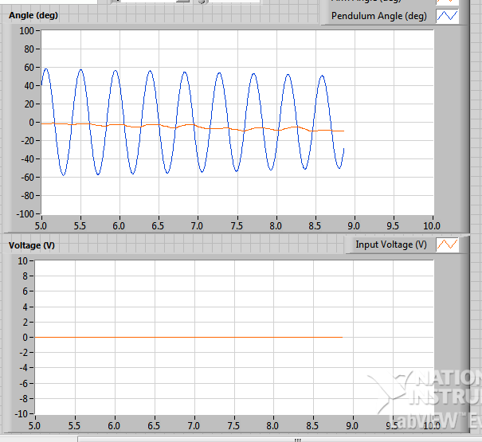

5. While still holding the arm, examine the response of Pendulum Angle (deg) in the Angle (deg) scope. This is the response from the pendulum system.

6. Repeat Step 3 above and release the arm after several swings.

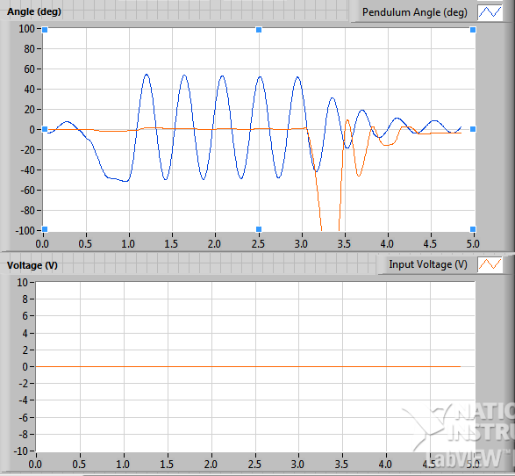

7. Examine the Pendulum Angle (deg) response when the arm is not fixed. This is the response from the rotary pendulum system. Given the response from these two systems pendulum and rotary pendulum – which converges faster towards angle zero? Why does one system dampen faster than the other?

The system when arm is not fixed converge faster towards zero because when arm is released the opposite effect is caused to damp the system faster.

8. Stop the VI by clicking on the Stop button.

Friction

1. Run the QNET_ROTPENT_Simple_Modeling.vi.

2. In the Signal Generator section set: Amplitude = 0.00 V Frequency = 0.25 Hz Offset = 0.00 V111

3. Change the Offset in steps of 0.10 V until the pendulum begins moving. Record the voltage at which the pendulum moved.

|  |  |
| --- | --- |
|  |  |

4. Repeat Step 3 above for steps of -0.10 V.

|  |  |
| --- | --- |
|  |  |

5. Enter the positive and negative voltage values needed to get the pendulum moving in Table 10.1. Why does the motor need a certain amount of voltage to get the motor shaft moving?

|  |  |  |  |
| --- | --- | --- | --- |
| Description | Symbol | Value | Unit |
| Positive Coulomb Friction Voltage | Fp | 1.8 | V |
| Negative Coulomb Friction Voltage | Fn | -2.4 | V |

6. Stop the VI by clicking on the Stop button.

Moment of Inertia

1. Using references QNET User Manual and QNET Practical Control Guide, calculate the moment of inertia acting about the pendulum pivot.

2. Run the QNET_ROTPENT_Simple_Modeling.vi

3. In the Signal Generator section set: Amplitude = 1.00 V Frequency = 0.25 Hz Offset = 0.00 V

4. Click on the Disturbance toggle switch to perturb the pendulum and measure the amount of time it takes for the pendulum to swing back-and-forth in a few cycles (e.g. 4 cycles).

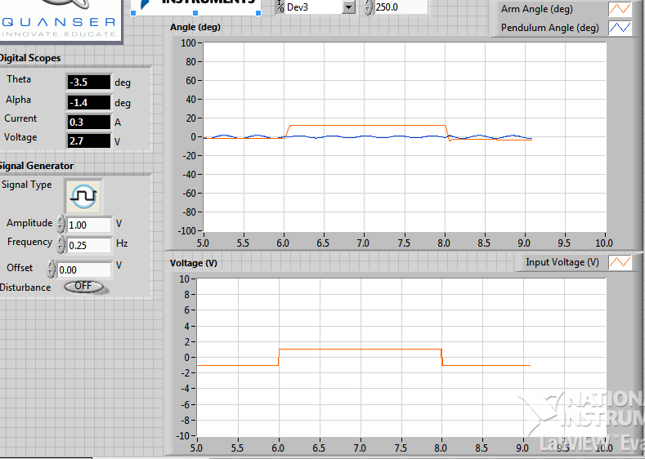

5. Find the frequency and moment of inertia of the pendulum using the observed results. See QNET Practical Control Guide to see how to calculate the inertia experimentally and make sure you fill the following

|  |  |  |  |
| --- | --- | --- | --- |
| Description | Symbol | Value | Unit |
| Cycles | Ncyc | 4 |  |
| Duration | delT | 2.84 | s |
| Frequency | F | 1.38 | Hz |
| Pendulum moment of inertia | Jp,exp | 2.15x10^-3 | Kg.m2 |

6. Compare the moment of inertia calculated analytically in step 1 and the moment of inertia found experimentally. Is there a large discrepancy between them?

Yes there is large discrepancy due to change in frequency.

7. Stop the VI by clicking on the Stop button.

**Application:**

Understanding the characteristics of rotary pendulum system controller and it help us in future experiments and can benefit greatly from the concepts used in this lab.

**Issues:**

No issue found while performing the lab.

**Conclusion:**

In this lab we learned the rotary pendulum system controller and its relationship between stability and inertia of the system.

.

**Post lab:**

1. **What do you understand by friction and dampening?**

**Ans**

**Friction:** Friction is the resistance to motion of one object moving relative to another. It is not a fundamental force, like gravity or electromagnetism. Instead, scientists believe it is the result of the electromagnetic attraction between charged particles in two touching surfaces.

**Damping:** Damping is any effect, either deliberately engendered or inherent to a system that tends to reduce the amplitude of oscillations. In applied mathematics, damping is mathematically modelled as a force with magnitude proportional to that of the velocity of the object but opposite in direction to it.

1. **What is rotary inverted pendulum system?**

Ans: Rotary Inverted Pendulum (RIP) is an under-actuated mechanical system which is inherently nonlinear and unstable. These comprise the linear, nonlinear time invariant, self-learning and adaptive nonlinear controllers.The system consists of a rotational arm and a pendulum where the rotational arm is actuated by a motor with the objective of balancing the pendulum in the inverted position.